7.37: a) 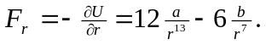

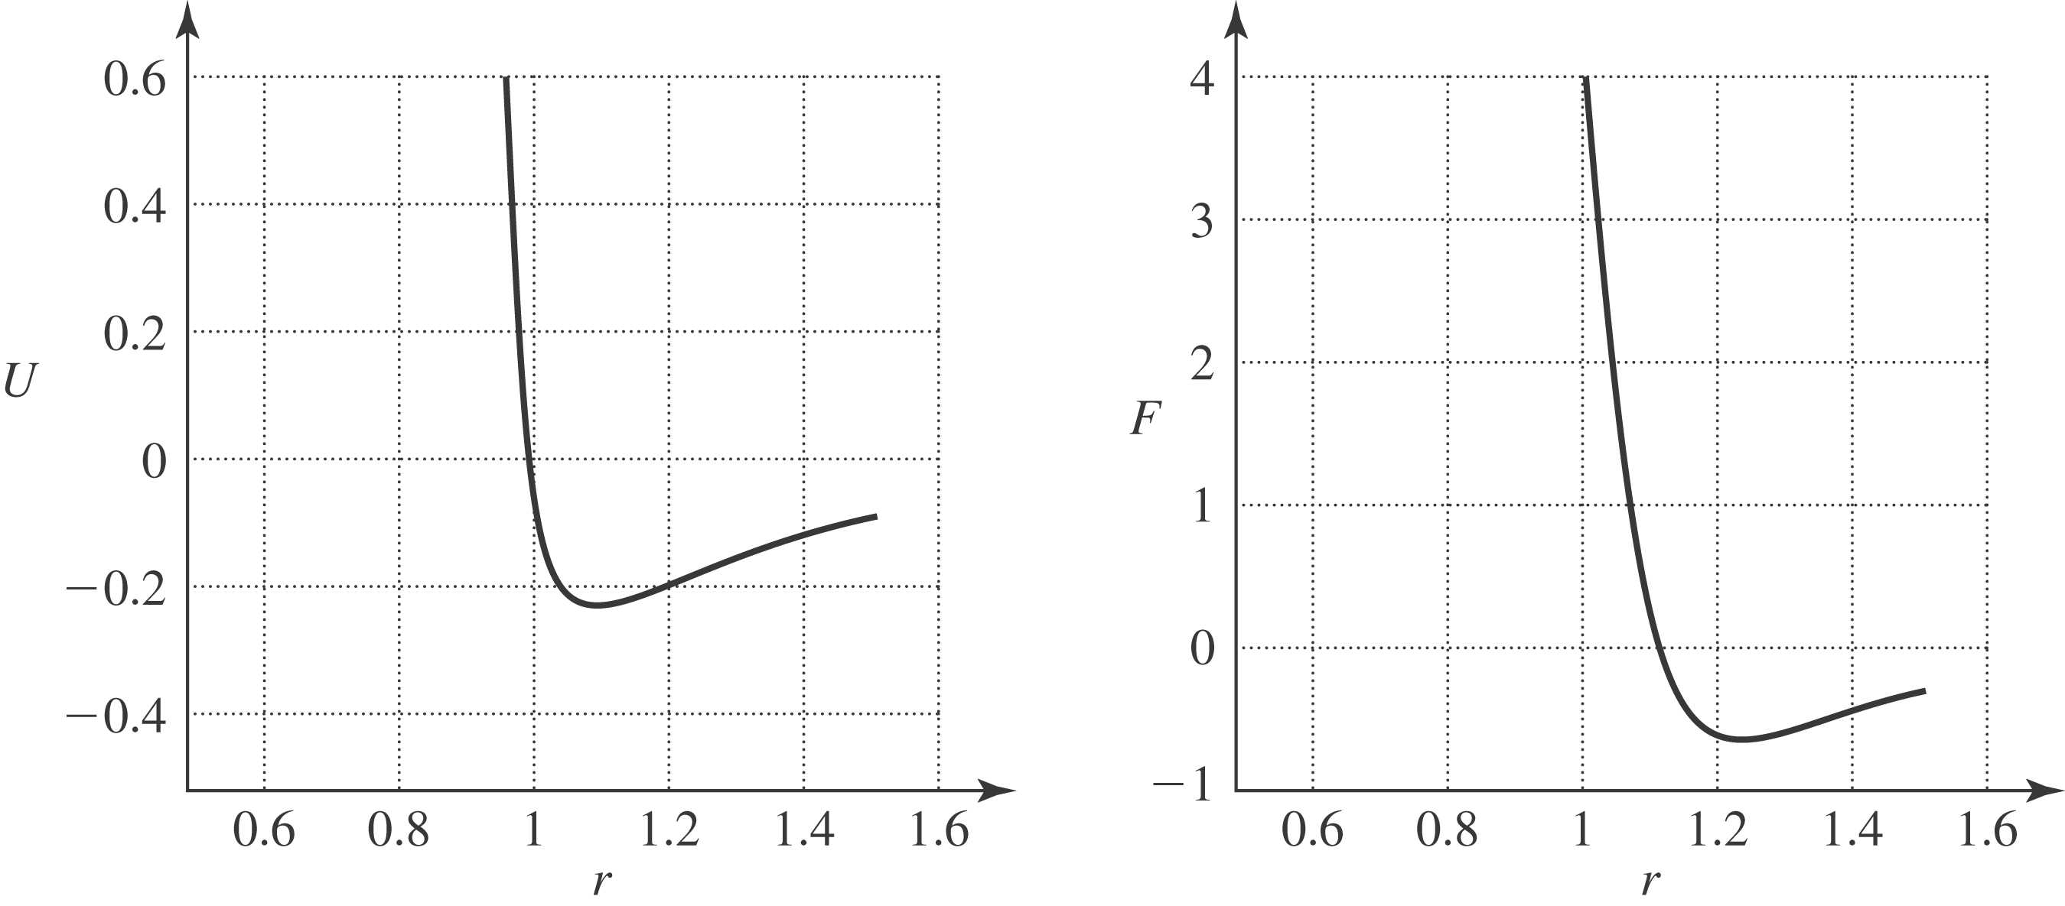

b) Setting 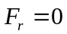 and solving for r gives 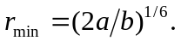 This is the minimum of potential energy, so the equilibrium is stable.
c)
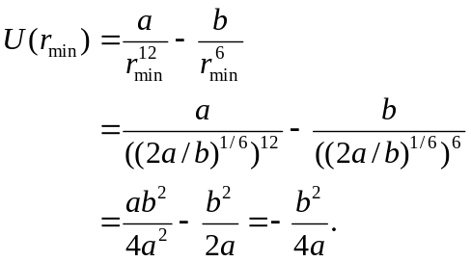
To separate the particles means to remove them to zero potential energy, and requires the negative of this, or 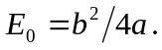 d) The expressions for 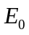 and 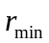 in terms of a and b are
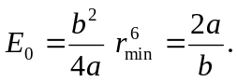
Multiplying the first by the second and solving for b gives 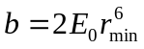, and substituting this into the first and solving for a gives 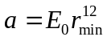. Using the given numbers,
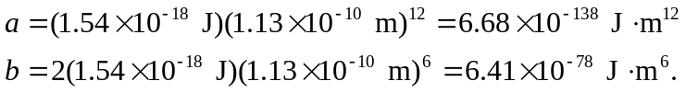
(Note: the numerical value for a might not be within the range of standard calculators, and the powers of ten may have to be handled seperately.)

